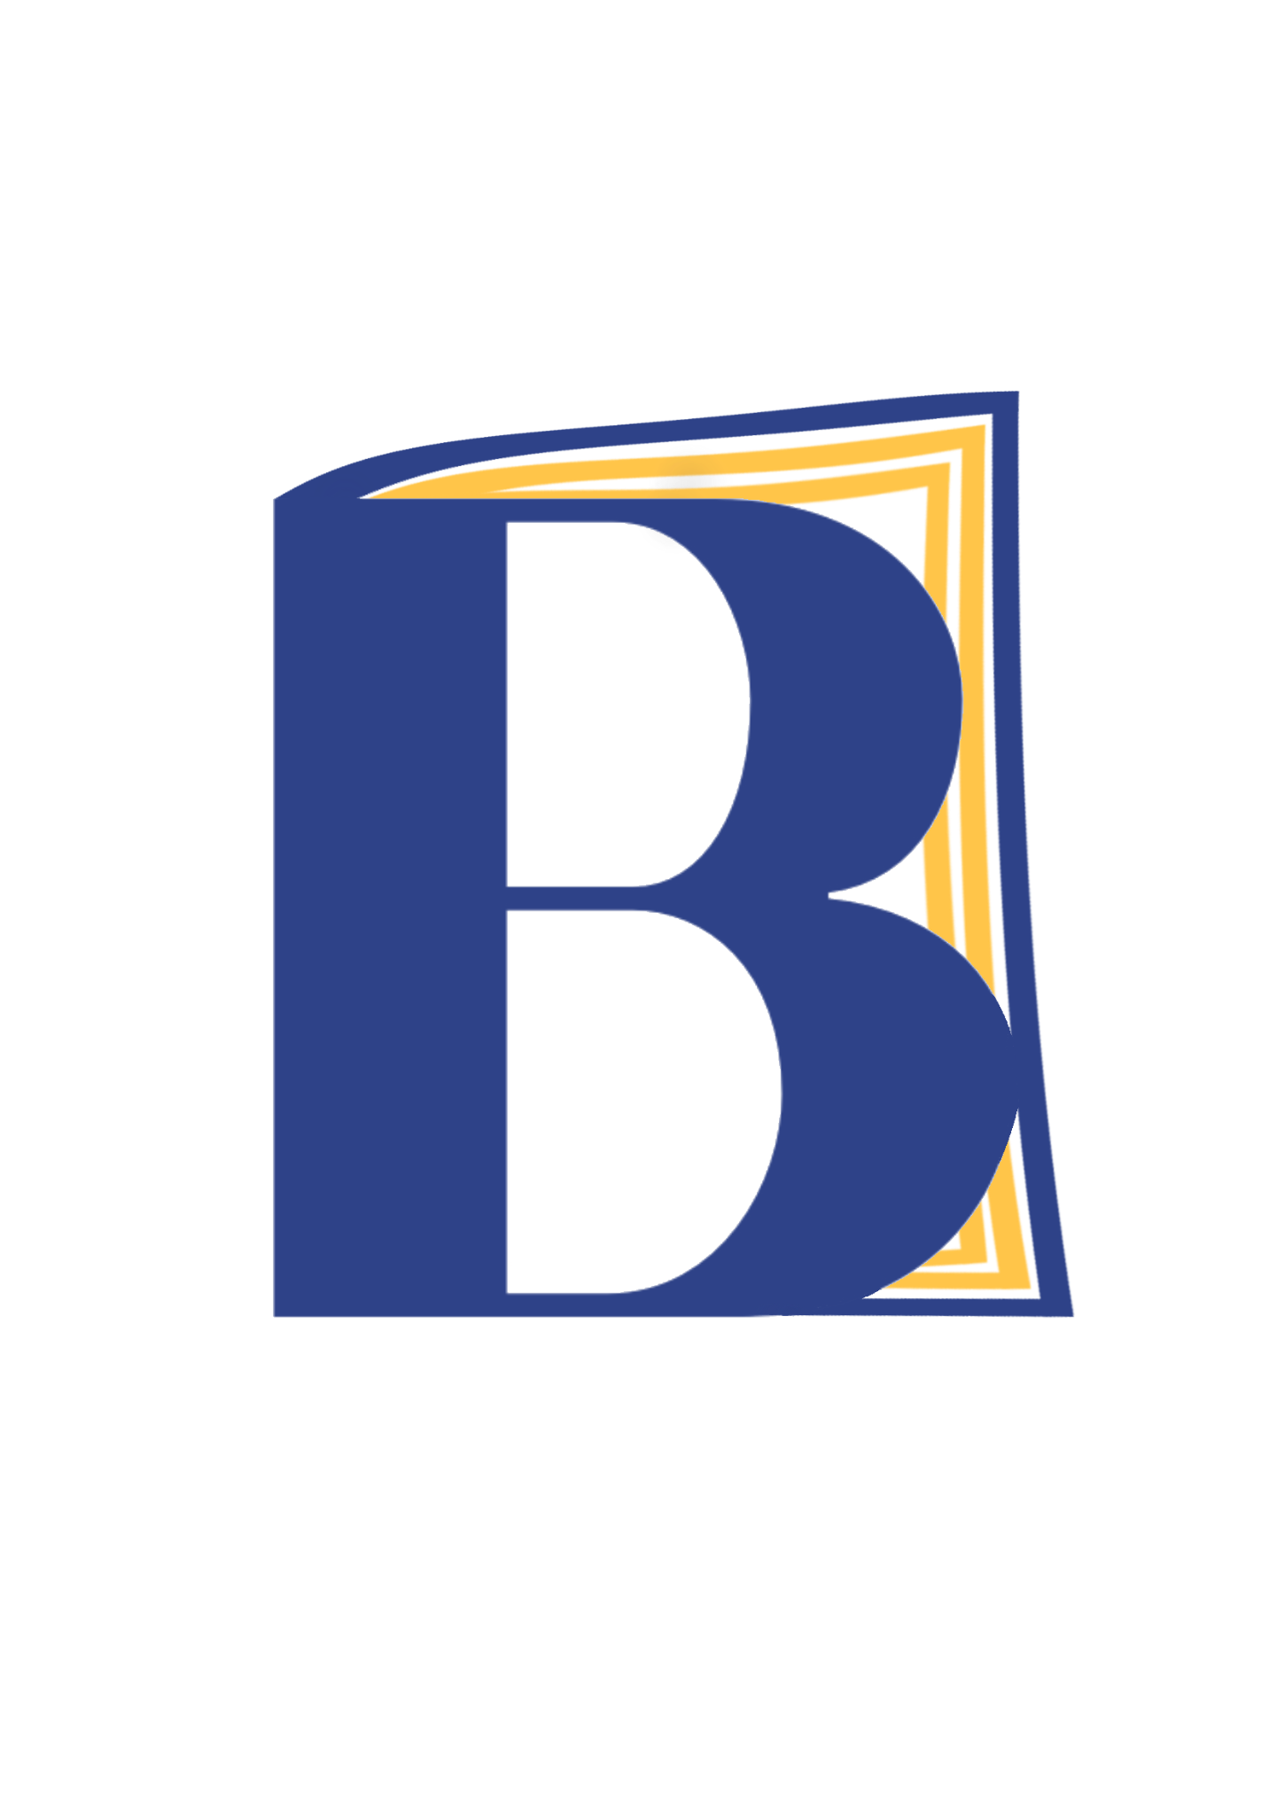 | Resources for Families in North Carolina  Recommended by Building Bonds Through Books  In addition to the book provided by BBTB, here are some resources families may find helpful in navigating education in addition to community resources. We have also provided a supplemental reading list that your local librarian may help you find!
1. Mothers And Their Children (MATCH) (all ages)  http://www.mothersandtheirchildren.org/contact_us.aspx  Located on the grounds of the North Carolina Correctional Institution for Women (NCCIW) in Raleigh, North Carolina, MATCH provides a homelike visitation center where children can visit with their mothers. If you have a loved one in this facility, please use the link provided above to contact MATCH and learn more about how you can use their services. |  |  | 4. Wake County Public Libraries (all ages)  https://www.wake.gov/events?field_department_target_id=25&field_event_type_target_id=All&&location=All  The libraries in Wake County host many events for all family members, including K-5th adventures, book clubs, family storytime, and other activities for various age groups. You can filter by location and audience age range for specific events to suit your family.
2. Big Brothers Big Sisters of the Triangle (ages 6-14)  https://bigstri.org/enroll-a-child/  Telephone: (919)850-9772  BBBS offers a mentorship program that helps children become more confident, more likely to steer clear of drugs and alcohol, do better in school, get along better with their family and friends and feel better about themselves. To apply, you can fill out the form on the page in the link provided, and mail the form and a copy of your child’s most recent report card to 808 Aviation Parkway, Suite 900  Morrisville, NC 27560. |  |  | Reading List:  Grade Level Pre-K - 3:  Missing Daddy by Mariame Kaba & Bria Royal  - Our Moms (Living with Incarcerated Parents) by Q. Futrell  - Kennedy’s Big Visit by Daphne Brooks  - My Daddy’s in Jail by Anthony Curcio
3. Charlotte Mecklenberg Public Library (all ages)  https://www.cmlibrary.org/services/childrens-services (ages birth - 11)  https://www.cmlibrary.org/services/teen-services (ages 12-18)  The CMPL offers reading programs for children, VolunTeen opportunities for teens, and student services, including homework help, for all grade levels.  Please refer to our National Resources for further assistance! |  |  | Grade Level 4+:  - Amber Was Brave, Essie Was Smart by Vera B Williams  - Jakeman by Deborah Ellis  - An Inmate’s Daughter by Jan Walker  Grade Level 6+:  - All I Ever Wanted...Stories of Children of the Incarcerated by Erika Duncan, Tanasha Y. Gordon  Parents/Guardians:  - Children with Incarcerated Mothers Separation, Loss, and Reunification by Julie Poehlmann-Tynan, Danielle Dallaire

